DFE report

1. Describing the data:
   1. There are 54675 genes overall
   2. There are 99 patients in total
   3. The samples in each class are:
      1. 49 samples for M (acute myocardial infarction)
      2. 50 samples for H (healthy)
   4. After removing 47 genes we are left with 54628
2. WRS:
   1. 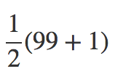Under the null model there is equal probability for getting + or – sample => p = 0.5. Which means that the value for M will be the average.

And the Total RS for M is 99\*50=2450.

* 1. The minimal value for RS(g) is when we will arrange all the M Samples in the lowest indices. Which means 1+2+…+49 = 1225.
  2. 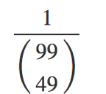There is only one model which satisfies RS = m. Which means that the probability for getting the exact RS = m is like choosing one order from the whole ordering options.
  3. Same as above there is only one ordering which can produce a situation where RS(g) = m+1. This ordering will be accepted when we will replace the last M rank with H, considering the RS(g) = m ordering as a baseline.
  4. For getting RS(g) = m+2 there are two ordering options:
     1. Switch between M48 and H50, taking the RS(g)=m ordering as a baseline.
     2. Switch between M49 and H50 and then switch between M48 and M49
     3. Taking these two ordering options to consideration we get P(RS(g)) = m+2 => 2\*

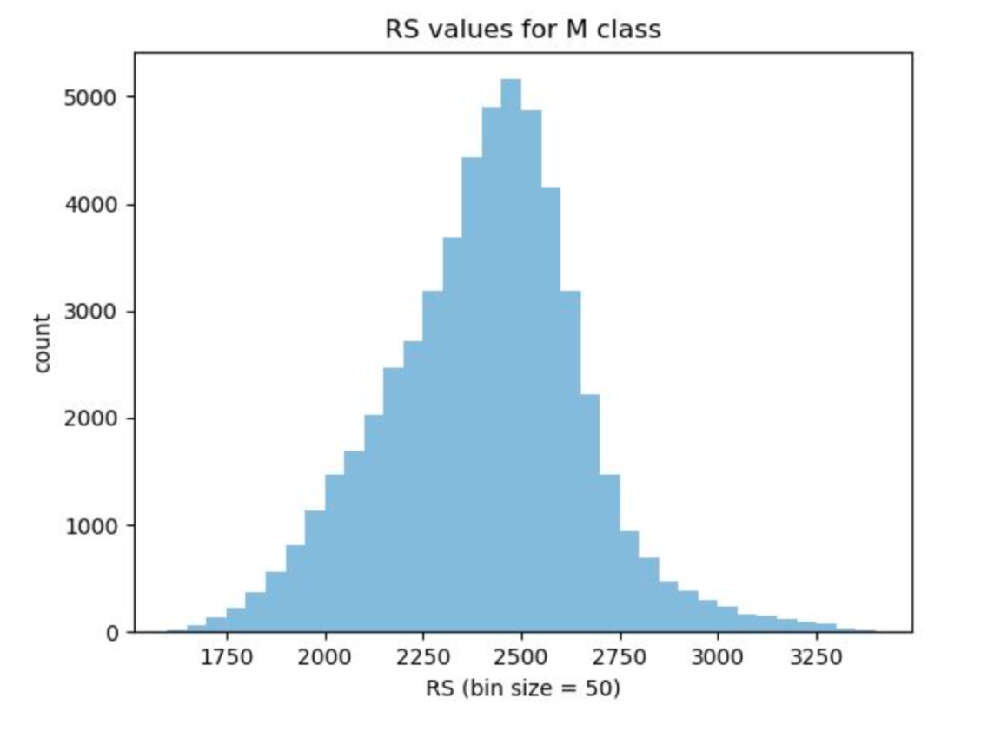

* 1. WRS – p values for M vs H:

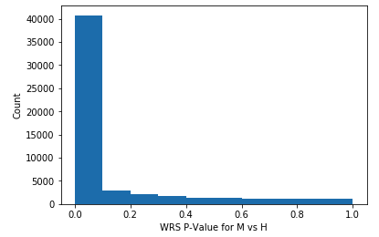

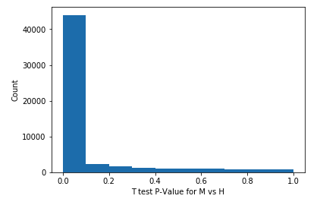

* 1. T test – p values for M vs H